Florida department of transportation

Impact of Wide Base Tires on Pavement Damage

# Background

The Federal Highway Administration has sponsored a national study to assess the impact of wide base tires on pavement damage. As part of this study, the Florida Department of Transportation (FDOT) has constructed and instrumented two test sections to measure pavement response. This report documents the effort to construct, instrument, and test these sections.

# FDOT’s Accelerated Pavement Testing Facility

Florida’s Accelerated Pavement Testing (APT) facility is housed within the State Materials Research Park in Gainesville. The original test lanes measured 150 feet long and 12 feet wide. A recent expansion of the test track extended each lane an additional 300 feet. The supporting soil layers consist of a 10.5 inch limerock base over a 12 inch mixture of limerock and native A-3 soil. Two additional 50 foot long test tracks (referred to as the test pits) are enclosed by a sump with an interconnecting channel system for controlling the water table. A photograph of the original test tracks and empty test pits are shown in FIGURE 1.

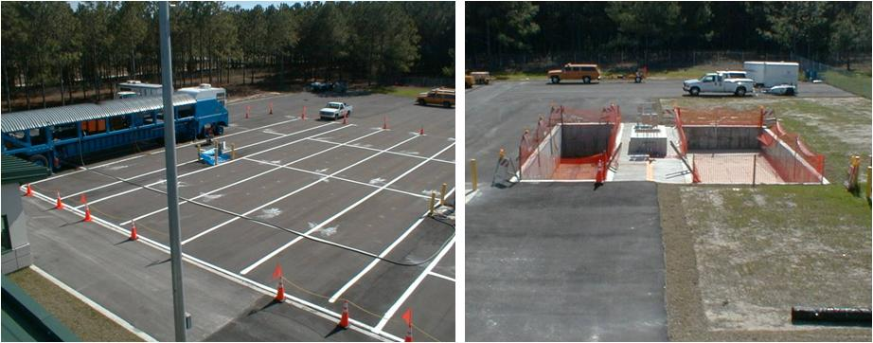

FIGURE 1 HVS Test tracks and test pits

Accelerated loading is performed using a Heavy Vehicle Simulator (HVS), Mark IV model. The HVS can apply wheel loads between 7 and 45 kips at speeds of 2 mph to 8 mph along a 30-foot test strip. The effective test segment within this span is approximately 20 feet. The remaining 5 feet, at either end of the test strip, allows the load wheel to reach programmed parameters controlling load and speed levels. Wheel wander of up to 30 inches can be induced. A heater system and insulated panels (shown in FIGURE 2) maintain a constant testing temperature within the test section area.

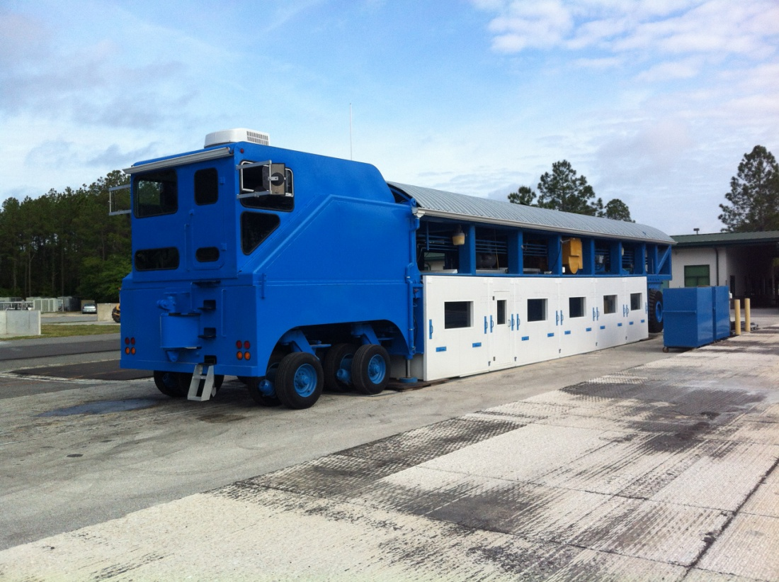

FIGURE 2 Insulated panels on HVS

# Construction

## Test Section Construction

Two test sections were constructed during October 2012. One section was constructed on the east test pit while the second was constructed on lane 7 of the test track extension. The test pit pavement consisted of two similar 1.5 inch Superpave (SP-12.5) layers with a PG 67-22 asphalt binder. The test track consisted of a 1.5 inch SP-12.5 layer with a PG 67-22 asphalt binder, a 1.5 inch SP-12.5 layer with a PG 76-22, and a 1.0 inch 4.75 mm mixture with a PG 76-22. The pavement sections were constructed in accordance with FDOT specifications and standards. The pavement structures for these sections are shown in FIGURE 3.



FIGURE 3 Pavement structure of test sections

## Material Sampling

### Supporting Granular Layers

Both test sections had similar supporting granular layers as indicated in FIGURE 3. A summary of laboratory test results is included in TABLE 1. The resilient modulus values listed in this table were obtained using the relationship developed from each individual test (resilient modulus versus bulk stress - with bulk stress, Θ, defined as Θ **=** σ1 + σ2 + σ3). The resilient modulus values are an average of two individual tests from each sample location. The resilient modulus samples were compacted to within 1 pound per cubic foot (pcf) of the maximum density and 0.5 percent of the optimum moisture content as determined by AASHTO T99 for the embankment and AASHTO T180 for the subgrade and base. The bulk stresses typically used to represent in-situ stresses of embankment, subgrade, and base layers are 11 psi, 16 to 18 psi, and 20 to 30 psi, respectively. The resilient modulus is determined by the following equation:

TABLE Granular Layer Properties

|  |  |  |  |  |  |  |  |  |  |  |  |
| --- | --- | --- | --- | --- | --- | --- | --- | --- | --- | --- | --- |
| AASHTO T99 or AASHTO T180 | | | | | AASHTO T307 | | | | | | |
| Material | Max Density (pcf) | Optimum Moisture (%) | Actual Density (pcf) | Actual Moisture  (%) | Bulk Stress, psi | | | | Avg. | k1 | K2 |
| 9 | 11 | 18 | 40 |
| Limerock Base | 114 | 12 | 112.5 | 10.3 | 11,657 | 13,083 | 17,365 | 27,482 | 27,482 | 3,297 | 0.5752 |
| Stabilized Subgrade | 114 | 11 | 113.8 | 9.3 | 12,901 | 14,332 | 18,553 | 28,197 | 18,553 | 4,079 | 0.5244 |
| Embankment | 115 | 11 | 113.3 | 9.3 | 11,539 | 12,806 | 16,538 | 25,035 | 12,806 | 3,687 | 0.5193 |

### Hot Mix Asphalt

HMA material was sampled from delivery trucks during construction (FIGURE 4) for mixture performance tests and three random cores were retrieved from each lane to verify in-situ density. In addition, 30 cores from each test section were extracted and shipped to the University of Illinois for further testing. TABLE 2 summarizes the gradations and volumetric properties of the asphalt mixtures.

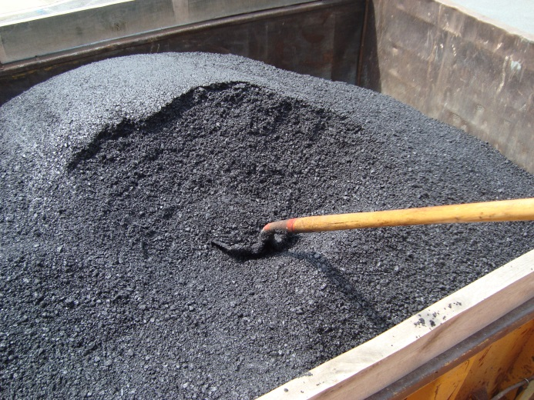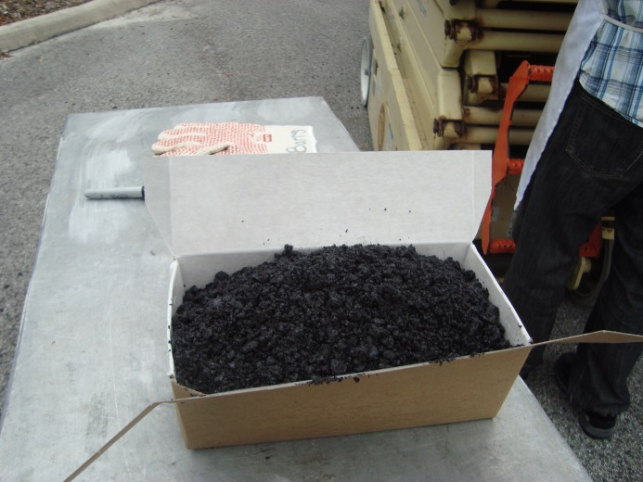

FIGURE Loose mixes sampled from trucks

TABLE 2 Gradation and Volumetric Property Data

|  |  |  |  |  |  |  |  |  |
| --- | --- | --- | --- | --- | --- | --- | --- | --- |
|  | Test Pit | | Test Track | | | | | |
|  | SP-12.5 | | 4.75 | | SP-12.5 | | SP-12.51 | |
| Sieve | JMF, % Passing | Plant Avg, % Passing | JMF, % Passing | Plant Avg, % Passing | JMF, % Passing | Plant Avg, % Passing | JMF, % Passing | Plant Avg, % Passing |
| 3/4" | 100 | 100.0 | 100 | 100.0 | 100 | 100.0 | 100 | 99.9 |
| 1/2" | 100 | 98.3 | 100 | 100.0 | 100 | 98.4 | 98 | 96.8 |
| 3/8" | 87 | 86.0 | 100 | 100.0 | 87 | 87.5 | 88 | 85.0 |
| #4 | 62 | 59.6 | 99 | 98.7 | 62 | 61.9 | 59 | 57.0 |
| #8 | 41 | 39.7 | 77 | 78.2 | 41 | 42.4 | 40 | 38.8 |
| #16 | 29 | 28.7 | 56 | 55.0 | 29 | 31.1 | 29 | 28.4 |
| #30 | 22 | 22.2 | 39 | 40.0 | 22 | 24.0 | 22 | 21.7 |
| #50 | 12 | 13.2 | 26 | 26.0 | 12 | 13.8 | 12 | 12.9 |
| #100 | 4 | 5.3 | 15 | 15.6 | 4 | 5.2 | 4 | 4.9 |
| #200 | 2 | 2.9 | 8.9 | 9.5 | 2 | 2.9 | 2 | 2.9 |
| Binder and Air Void Content | | | | | | | | |
| Binder Type | PG 67-22 (unmodified) | | PG 76-22 (modified) | | PG 76-22  (modified) | | PG 67-22  (unmodified) | |
| %AC | 5.1 | 4.7 | 6.5 | 6.3 | 5.1 | 4.9 | 5.1 | 4.9 |
| %AV | 4.0 | 4.0 | 4 to 6 | 4.6 | 4.0 | 3.9 | 4.0 | 3.3 |
| Core Density and Lift Thickness | | | | | | | | |
| Core Property | SP-12.5 | | 4.75 | | SP-12.5 | | SP-12.51 | |
| % Density | 94.2 | | 11.5 | | 94.8 | | 94.6 | |
| Lift Thickness, inch | 1.5 | | 0.9 | | 1.6 | | 1.4 | |
| Note: The SP-12.5 mixture placed on the test track was paved approximately 1 year prior to the mixture placed on the test pit. | | | | | | | | |

### Asphalt Mixture Performance Tester (AMPT)

The AMPT is a testing device designed to determine the asphalt mixture dynamic modulus for use in pavement structural design (e.g., the Mechanistic-Empirical Pavement Design Guide) and the flow number for the evaluation of potential mixture performance. The AMPT test provides a dynamic modulus master curve that indicates the modulus of asphalt mixture for any combinations of temperature and load frequency. AASHTO PP 61 standardizes the construction of dynamic modulus master curve using the AMPT. In addition, the flow number measured from the AMPT enables the evaluation of rutting resistance of asphalt mixtures.

In this study, dynamic modulus and flow number tests were conducted in accordance with AASHTO TP 79. The plant mix sampled during construction was compacted using the Superpave Gyratory Compactor (SGC). Three replicates were made for dynamic modulus tests and one replicate was prepared for the flow number test according to AASHTO PP 60. The AMPT test setup is shown in FIGURE 5. FIGURE 6 represents dynamic modulus master curves generated for the three different mixtures. A temperature of 20 °C was used as a reference temperature. Also, the results of flow number are shown in FIGURE 7.

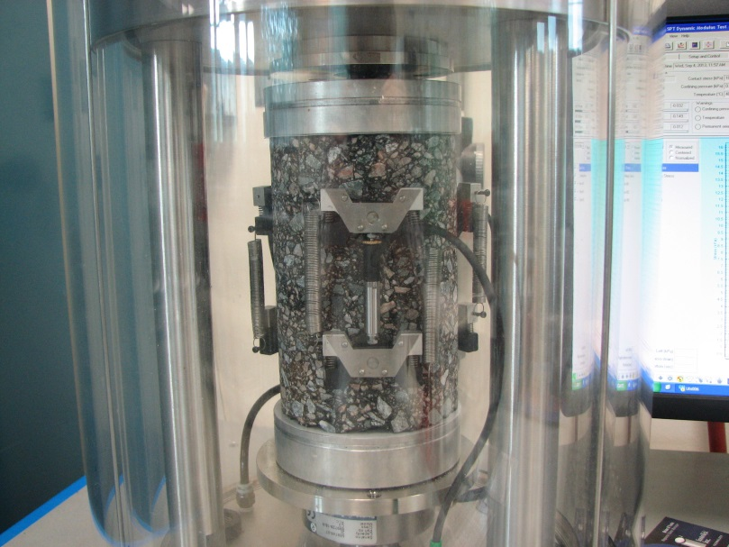

FIGURE AMPT test setup

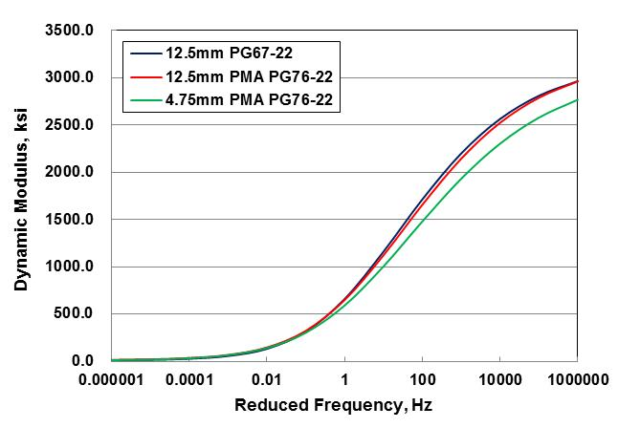

FIGURE Dynamic modulus master curves

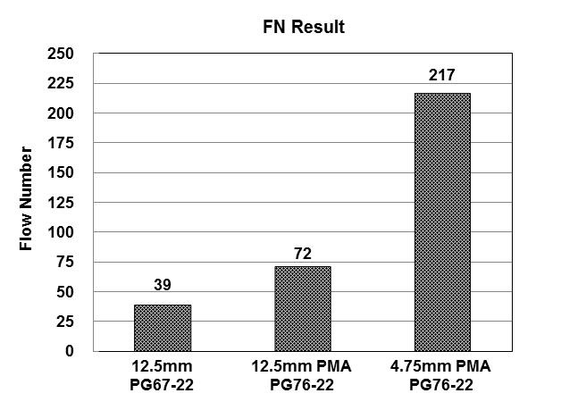

FIGURE Flow number results

### Superpave Indirect Tension (IDT) Test

Superpave IDT tests were conducted on mixtures to determine key mixture fracture properties. The standard Superpave IDT tests, including resilient modulus, creep compliance and strength test, were performed at 10 °C. A complete description of the test procedures and data analysis is presented elsewhere (). The plant mixes sampled from truck were compacted using the SGC. Three replicates per mixture type were prepared and tested. summarizes the information of three cut specimens for testing and shows the configuration of Superpave IDT test setup.

TABLE 3 Information of Cut Specimens for Superpave IDT Tests

|  |  |  |  |  |
| --- | --- | --- | --- | --- |
| Mixture  Types | Specimen  Number | Air Voids  (%) | Average Diameter (inch) | Average Thickness (inch) |
| 12.5mm  PG67-22 | 1 | 6.9 | 5.93 | 1.53 |
| 2 | 6.8 | 5.92 | 1.57 |
| 3 | 6.5 | 5.92 | 1.51 |
| 12.5mm PMA PG76-22 | 1 | 7.0 | 5.93 | 1.49 |
| 2 | 6.7 | 5.92 | 1.51 |
| 3 | 6.9 | 5.92 | 1.48 |
| 4.75mm PMA PG76-22 | 1 | 7.3 | 5.92 | 1.51 |
| 2 | 6.7 | 5.92 | 1.50 |
| 3 | 6.9 | 5.92 | 1.54 |

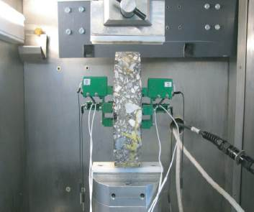

FIGURE 8 Superpave IDT test setup

TABLE 4 summarizes the results of Superpave IDT tests and FIGURE 9 exhibits three key mixture fracture properties found to be the most strongly related to cracking performance of asphalt pavements *(2, 3)*. Generally, a higher ER value is associated with a higher FE and a lower creep rate. The aforementioned trend is consistent with the results shown in FIGURE 9(a) through (c). In particular, it was found that 4.75 mm mixture with polymer-modified PG 76-22 binder had a relatively higher FE, lower creep rate, and higher ER values that may result in better fracture resistance than the 12.5 mm mixtures.

TABLE 4 Superpave IDT Test Results

|  |  |  |  |  |  |  |  |  |  |  |  |
| --- | --- | --- | --- | --- | --- | --- | --- | --- | --- | --- | --- |
| Mixture Types | Temp. (°C) | m-value | D1  (1/psi) | Creep Compliance (1/Gpa) | St (Mpa) | MR (Gpa) | εf  (10-6) | FE (KJ/m3) | DCSEf (KJ/m3) | Creep Rate (1/psi·sec) | ER |
| 12.5mm PG67-22 | 10 | 0.46 | 3.55E-07 | 1.281 | 2.44 | 13.97 | 1300.23 | 2.30 | 2.09 | 3.83E-09 | 2.81 |
| 12.5mm PMA PG76-22 | 10 | 0.41 | 4.17E-07 | 1.058 | 2.54 | 13.16 | 1533.00 | 2.80 | 2.55 | 2.77E-09 | 4.16 |
| 4.75mm PMA PG76-22 | 10 | 0.35 | 3.84E-07 | 0.658 | 2.90 | 14.21 | 2050.62 | 4.40 | 4.10 | 1.47E-09 | 10.93 |

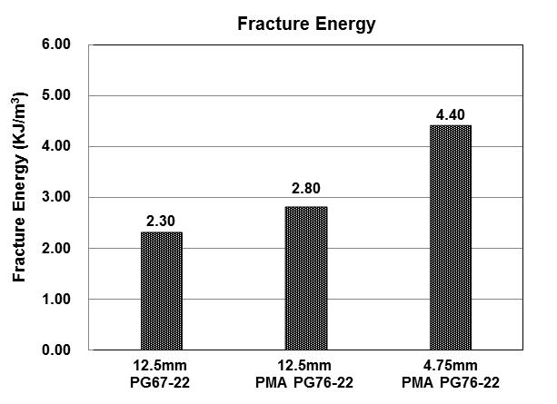

1. Fracture energy

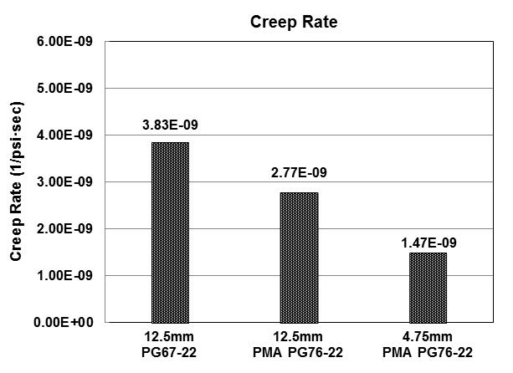

1. Creep rate

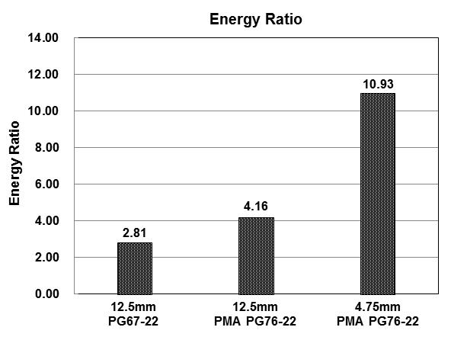

1. Energy ratio

FIGURE 9 Key mixture fracture properties determined from Superpave IDT tests

# Instrumentation

Each test section was instrumented to measure pavement response due to wheel loading. Prior to construction, each embedded sensor was placed in the appropriate location, labeled, and checked for adequate response. Immediately after construction, the response was again checked to make sure each embedded sensor survived the compaction and heat associated with the placement of HMA. Standard sensor installation methods used by FDOT can be found on the State Materials Office website (). TABLE 5 summarizes the types of sensors and locations the sensors were placed. Diagrams of the exact sensor locations are shown in FIGURE 10 and FIGURE 11. Instrumentation data was collected with a mobile National Instruments data acquisition (DAQ) system (FIGURE 12) at 200 Hz for the surface gauges and pressure cells and at 100 Hz for the embedded H-gauges.

TABLE Sensor Types and Locations

|  |  |  |  |  |
| --- | --- | --- | --- | --- |
| Sensor  Type | Number of Sensors per Test Section | Model | Vertical Location | Offset from Wheel Path |
| Surface strain gauge | 24 | Tokyo Sokki  PFL-30-11-5L | HMA surface | Transverse and longitudinal orientations at various offsets from wheel path edge |
| Asphalt strain gauge | 6 | Tokyo Sokki  KM-100HAS | Bottom of new HMA | Transverse and longitudinal orientations below tire center |
| Pressure cell | 2 | RST Instruments LPTPC09-S | Bottom of new HMA | Below tire center |
| Pressure cell (Test Pit only) | 2 | Geokon 3500 | Bottom of base | Below tire center |



(a) Test pit instrumentation plan view



(b) Test pit instrumentation elevation view

FIGURE Test pit instrumentation layout



(a) Test track instrumentation plan view



(b) Test pit instrumentation elevation view

FIGURE Test track instrumentation elevation view

## G:\Research\HVS Experiments\Asphalt\Wide-Base TPF\Photos\Photo Apr 11, 8 26 40 AM.jpgG:\Research\HVS Experiments\Asphalt\Wide-Base TPF\Photos\Photo Apr 11, 8 27 27 AM.jpg

FIGURE 12 Mobile DAQ system

# HVS Loading

Several combinations of inflation pressure, tire load, and pavement temperature were used for each tire type as shown in TABLE 3. HVS loading was initiated January 24 on the test pit using the dual tire and was completed on February 12. HVS loading on the test track began on February 20 using the 445 mm wide base tire and was completed on April 10. A main motor failure during loading of the test track delayed testing for more than two weeks. TABLE 6 shows the load and temperature combinations that were used.

TABLE HVS Test Matrix

|  |  |  |  |  |  |  |
| --- | --- | --- | --- | --- | --- | --- |
| Tire  Type | Inflation Pressure (psi) | Tire Load  (kips) | | | | |
| NGWB & Dual | 80 | 6 | 8 | 10 | 14 | 18 |
| NGWB & Dual | 100 | 6 | 8 | 10 | 14 | 18 |
| NGWB & Dual | 110 | 6 | 8 | 10 | 14 | 18 |
| NGWB & Dual | 125 | 6 | 8 | 10 | 14 | 18 |
| Dual Only | 60/110 | 6 | 8 | 10 | 14 | 18 |
| Dual Only | 60/110 | 6 | 8 | 10 | 14 | 18 |
| Each loading combination was conducted at 25⁰C, 40⁰C, and 55⁰C | | | | | | |

# REFERENCES

1. Roque, R., Buttlar, W. G., Ruth, B. E., Tia, M, Dickson, S. W., and Reid, B. *Evaluation of SHRP Indirect Tension Tester to Mitigate Cracking in Asphalt Concrete Pavements and Overlays.* Final Report of Florida Department of Transportation, University of Florida, Gainesville, Florida, 1997.
2. Zhang, Z., Roque, R., Birgisson, B., and Sangpetngam, B. Identification and Verification of a Suitable Crack Growth Law. *Journal of the Association of Asphalt Paving Technologists, Volume 70*, 2001, pp. 206-241.
3. Roque, R., Birgisson, B., Drakos, C., and Dietrich, B. Development and Field Evaluation of Energy-Based Criteria for Top-Down Cracking Performance of Hot-Mix Asphalt. *Journal of the Association of Asphalt Paving Technologists, Volume 73*, 2004, pp. 229-260.
4. Instrumentation of Florida’s Accelerated Pavement Testing Facility. Florida Department of Transportation, Gainesville, FL, 2011. Retrieved from <http://www.dot.state.fl.us/statematerialsoffice/pavement/research/apt/documents/instrumentation.pdf>